***Zomato Restaurant Data Analysis***

**Objective:**

We are analyzing the data and developing some useful insights to open a new restaurant.

**Objective Questions:**

Each question is answered and the Point of view is also mentioned.

**Que1**- **What is the total no. of tables present in the table?**

**Ans1**- There are two tables in the given Excel workbook one is present in the sheet named ***Raw Data*** which contains details of the restaurants and the second is present in the sheet named ***Country Description*** which contains details regarding countries and country codes.

**Point of View**: I simply look at the workbook and come to know about the tables present in the data.

**Que2**- **What is the total no. of attributes present in the data?**

**Ans2**- There are 20 columns present in the sheet named ***Raw Data*** and 2 columns present in the sheet named ***Country Description***.

**Point of View**: I simply count the columns in both the sheets.

**Que3**- **How many categorical columns are there in the data?**

**Ans3**- 15 Categorical columns in the data.

**Point of View**- Categorical are those columns that have finite values and can be further divided into categories.

**Que4**- **The data consists of some inconsistent and missing values so ensure that the data used for further analysis is cleaned.**

**Ans4**- Yes data had some missing values and inconsistency. I rectified them.

Point of View: First of all, I put the count blank formula at the end of each column to check if is there any blank cells in the columns and I found that there are 9 blanks in the column named Cuisines and filled those columns according to the country code of the restaurants. After that I found that 0 is present in the column names **Longitude, Latitude, and Votes**, then I checked the average of all the columns and I replaced all the Zeros with the **average of the particular column respectively**. I created a new column named year and removed duplicates in the whole data but no duplicates were found.

**Que5**- **Using the Lookup functions, fill up the countries in the original data using the country code.**

**Ans5**- I used the VLOOKUP function to fill up the countries.

**Point of View**- I have created a new column named country in the ***Raw Data*** sheet and used the VLOOKUP function [VLOOKUP (C2,' country description'!$A$1:$B$16,2,0) ] after using this formula I got the country name and later on I used fill down button fill all country names.

**Que6**- **Create a table to represent the number of restaurants opened in each country.**

**Ans6**- There are two ways to do this **1. Use the Count if formula, 2. Use the Pivot table**.

**Point of View**- I solved this question both ways, I solved this question by creating a new column No. of Restaurants in sheet name ***Country description*** in the workbook.

I have pasted the screenshot of both the methods below please use it for the reference.

**The below screenshots are taken from the Excel sheet named Country Description.**

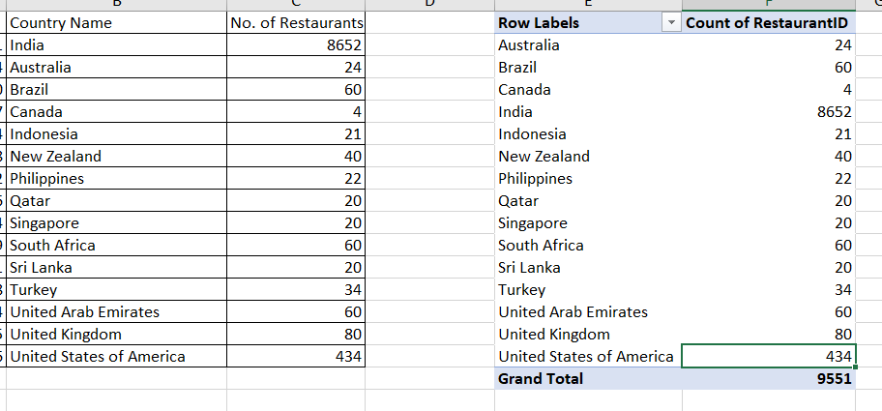

**Que7**- **Also, the management wants to look at the number of restaurants opened each year, so provide them with something here.**

**Ans7**- I used the Pivot Table for this answer in the sheet named Year.

**Point of View**- I solved this question with the help of Pivot Table and also pasted the screenshot below for reference.

**The below screenshots are taken from the Excel sheet named Year.**

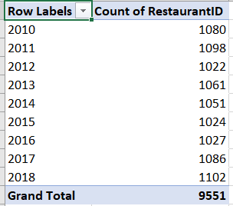

**Que8**- **What is the total number of restaurants in India in the price range of 4?**

**Ans8**- There are two ways to solve this question **1 Countifs, 2 Pivot Table**.

**Point of View**- I solved this question by both of the methods in the sheet named **Price Range**. Also pasting the screenshot below for reference.

**The below screenshots are taken from the Excel sheet named Price Range.**

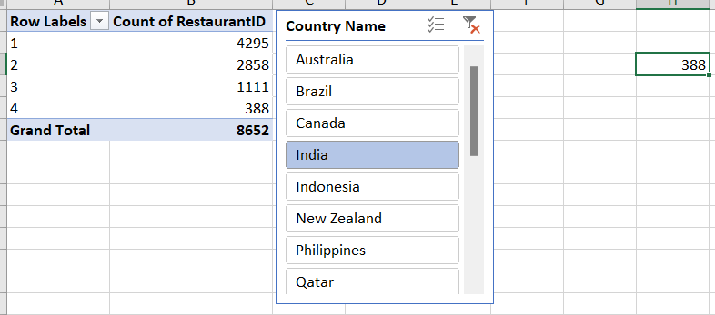

**Que9**- **What is the average number of voters for the restaurants in each country according to the data?**

**Ans9**- For this question we have to make another Pivot Table. But before that, I am replacing the 0 with the average of the votes i.e. 156.91, so that the data should be correct.

**Point of View**- I solved this question by Pivot Table in the sheet named **Votes** and pasted the screenshot below for reference.

**The below screenshots are taken from the Excel sheet named Votes.**

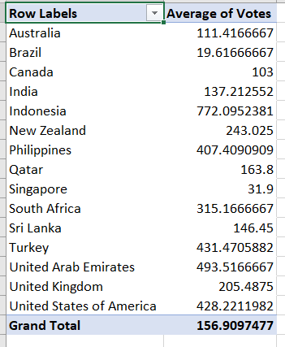

**Que10**- **Calculate the average rating for all the restaurants that have price_range < 4 and provide online delivery.**

**Ans10**- The average rating for all restaurants that have price_range < 4 and provide online delivery is 3.273812.

**Point of View**- I have used nested if here along with array function in the sheet named as ***Country Description***, the formula is pasted below for the reference {=AVERAGE(IF(('Raw Data'!P2:P9552<4)*('Raw Data'!M2:M9552="Yes"),' Raw Data'!S2:S9552)) }

**Que11**- **Using Conditional formatting highlight the rows of restaurants that are located in the countries or cities that you’ve suggested to the management for opening new restaurants.**

**Ans11-** All countries are highlighted.

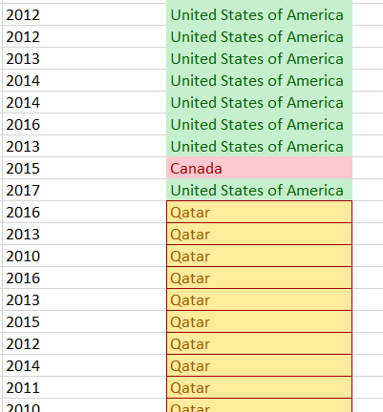**Point of View**- I used conditional formatting and highlighted the countries based on online delivery, Number of restaurants, Price range, and Average votes. The screenshot is pasted below for the reference.

**Que12 - Create a new customized price column that consists of the abbreviation/symbol of the currency along with the Average_cost_for_two value**.

**Ans12-** I used the TRIM function along with MID and FIND function in the new column created named as ***Updated Cost with Abvr***.

**Point of View** - =TRIM(MID(K2,FIND("(",K2)+1,FIND(")",K2)-FIND("(",K2)-1))&R2

**The below screenshots are taken from the Excel sheet named Raw Data.**

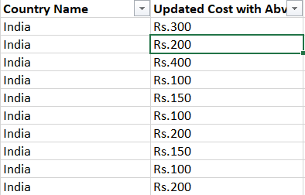

**Que13 How can you create an array formula in Excel or Google Sheets to count the number of restaurants listed that do not offer online delivery, are in the lowest price range, and have an average cost for two people less than or equal to 250 Indian Rupees?**

**Ans13** The number of restaurants that do not offer online delivery has the lowest price range and has an average cost of two people less than or equal to 250 in the country India is 1694 by using the array function.

**Point of View** To solve this question I have converted the average cost for two which are in different currencies for different countries into rupees and then I have used the array formula.

Formula used: {SUM(IF((('Raw Data'!P2:P9552=1)*('Raw Data'!M2:M9552="No")*('Raw Data'!S2:S9552<=250)),1,0))}

In the above formula, P represents the Price range, M represents Has online delivery, and S represents Currency updated.

**The below screenshot is taken from the Excel sheet named Country Description.**

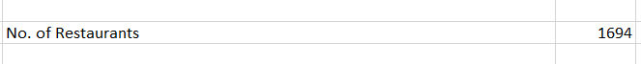

The value 1694 is present in cell number J7 in the sheet named country description.

**Subjective Questions:**

**Que1 Suggest a few countries where the team can open newer restaurants with lesser competition. Which visualization/technique will you use here to justify the suggestions?**

**Ans1** I suggested three countries for opening the new restaurants based on No. of restaurants already present there, average of votes, based on types of deliveries and price range.

1. **Canada**
2. **Qatar**
3. **United States of America**

**Insights and Suggestions:**

● **Canada** has only 4 restaurants. These numbers are significantly lower than in other countries, such as India, where there are over 8,600 restaurants. The average rating for Canada is reasonably high at 3.575, indicating a market with growth potential.

● **Qatar** has 20 restaurants with an average rating of 4.06, This suggests that while there is some competition, the market is not saturated, leaving room for new entries.

● The **United States of America** has 434 restaurants with an average rating of 4.01, reflecting a balance between online and table bookings and relatively high customer satisfaction.

**The below charts are taken from the Excel sheet naming all pivots and charts.**

**Que2 Come up with the names of States and cities in the suggested countries suitable for opening restaurants.**

**Ans2** I suggested 5 cities in which new restaurants can be opened based on the number of restaurants that were already present there and their ratings.

1. **Potrero**
2. **Miller**
3. **Cochrane**
4. **Consort**
5. **Doha**

**Insights and Suggestions:**

● **Cochrane** has only 1 restaurant. This suggests that competition is low there and has an average rating of 3.1 reflecting that there is an opportunity for new restaurants.

● **Consort** has only one restaurant, making it an ideal location with minimal competition. The average rating of 3 suggests room for improvement, offering an opportunity to introduce new dining experiences.

● **Doha** While Singapore has 20 restaurants, the consistent average rating of 4.06 is higher than the average of the market.

● **Miller** has 1 restaurant, the consistent average rating of 3.4 indicates steady demand. This presents an opportunity for new entrants to differentiate themselves with unique offerings.

● **Potrero** has only one restaurant with a low moderate rating of 3.3, This creates an opportunity for a new restaurant to capture the market by offering a superior dining experience.

**Below chart is taken from excel sheet named All Pivots and Charts**

**Que3 According to the countries you suggested, what is the current quality regarding ratings for restaurants that are open there?**

**Ans3 Approach:**

The Countries that I have selected for opening the new restaurants have a current quality average rating is more than 4, and also have less number of restaurants already present there.

**Insights:**

1. Canada has an average rating of 3.5. Qatar with a 4.06 rating. United States of America has an average rating of 4.0.
2. Qatar and the United States of America have wide differences in the number of hotels but ratings for both countries are similar.

**Recommendation:**

1. Get the average rating of each restaurant to understand whether the rating is good or not in the above countries restaurants have good ratings so its good to open new restaurants in the above country.

**The below screenshot is taken from an excel sheet named All Pivots and Charts**

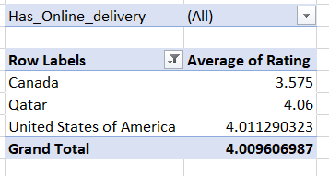

**Que4 Also, what is the current expenditure on food in the suggested countries, so we can keep our financial expenditure in control?**

**Ans4 Approach:** To answer the above question we have to check the average cost of 2 people in suggested countries and the currency would be in the same manner, so for that I converted all currencies into Indian Rupees so that we can compare easily and fairly.

1. Average cost in Canada = Rs.3045
2. Average cost in Qatar = Rs.5146.25
3. Average cost in the United States of America = 2196.77

**Insights:**

1. Canada having only 4 restaurants with an average cost of 3045 INR, indicates a good opportunity for growth because of low competition and economical pricing.
2. Qatar has the highest average cost of the above-suggested countries.
3. The United States of America has the lowest average cost among the suggested countries. This may indicate that people are more budget-conscious.

**Recommendation:**

1. Canada shows a significant opportunity for new restaurants because of the less competitive market along with economic expenditure. Expanding here will give us a strong opportunity to capture a good customer base.
2. In Qatar, people are willing to spend more. Offering good quality of food and services will further help improve the customer relations. As mentioned before, offering cuisine-specific restaurants with a high focus on the quality of food and a good dining experience will gain us a good advantage in capturing the market despite the high competition.
3. As customers are more budget-conscious in the United States of America, focus on budget-friendly restaurants is essential. Offering discounts or combo deals may help in attracting more customers.

**The below chart is taken from an excel sheet named All Pivots and Charts**

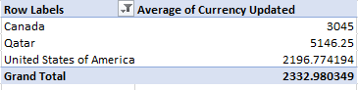

**Que5 Come up with the names of restaurants from the recommended states that are our biggest competitors and also those that are rated in the lower brackets, i.e. 1-2 or 2-3.**

**Ans5 Approach:** Here our biggest competitors are those restaurants that have ratings of more than 4, so for that, I created the Pivot table which shows restaurant names that have ratings of more than 4 as well as ratings under the bracket of 1-2,2-3.

**Insights:**

1. In the below data of these restaurants name for good competitor in the market.

**Recommendation:**

1. Doha has the highest number of restaurants rating above 4. There is no single restaurant that has the lowest rated restaurants among the suggested countries. This indicates that there is a clientele that is willing to spend on restaurants. Focus on providing a quality and unique experience will help capture a larger market and improve the average cost.

**The below chart is taken from Excel sheet named All Pivots and Charts**

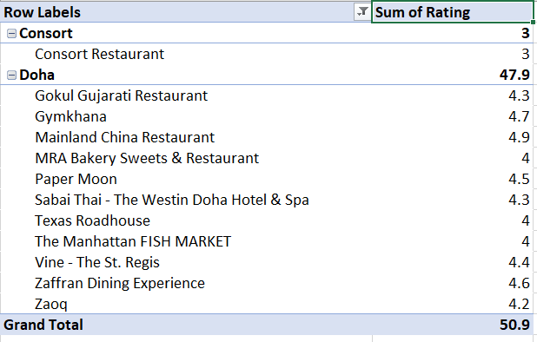

I also created 3D column chart to visualize the above in the pictorial form.

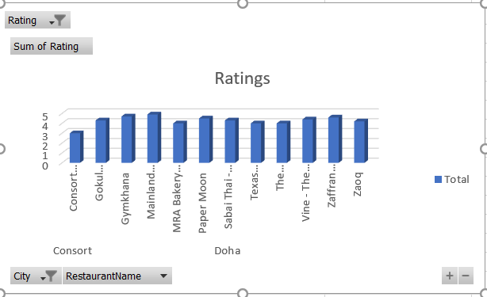

**Que6 Which cuisines should we focus on in the newer restaurants to get better feedback? Does the choice of cuisines affect the restaurant ratings?**

**Ans6 Approach:** Yes, Cuisines will definitely affect the restaurant's ratings, because each city has different cuisines liked in different areas, for this, I created the Pivot table. Through the pivot table, we can understand easily the restaurants, cuisines, and their rating as well. Cochrane city has cuisines Asian and Japanese which have ratings of more than 3, likewise, Doha city have, ore types of cuisines liked in different areas of the cities. Indian, Italian, and Chinese have ratings of more than 4, and so on.

**Insights:**

1. Restaurants in Cochrane and Consort serving Asian, Chinese, Canadian, and Japanese cuisine are only receiving average ratings.
2. Doha is receiving average ratings in almost all the cuisines available.

**Recommendation:**

1. In Cochrane, Chinese and Canadian cuisine are rated low. Focus on providing authentic Chinese cuisine with a unique dining experience will help capture the market.
2. Similarly, Consort is rated average in all global cuisines. The dining experience and authentic food should be given more importance.

**The below screenshot is taken from an excel sheet named All Pivots and Charts**

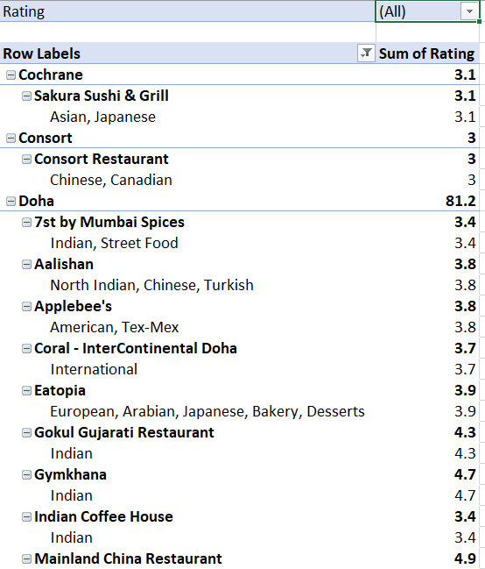

**Que7 According to our current data, should we go for online delivery and table booking? Does that affect the customer’s ratings?**

**Ans7 Approach:** Yes it affects the customer’s ratings because if we simply look at the average ratings of the restaurants that have no table bookings nor online deliveries is 2.67, but if the restaurants have both online deliveries and table bookings then the average becomes 3.6.

**Insights:**

1. Restaurants with online delivery have a higher average rating compared to others. This suggests that offering online delivery services can enhance customer satisfaction and overall ratings.
2. Similarly, restaurants that provide table booking options have a higher average rating compared to those that don’t. This indicates that customers value the convenience of reserving a table.

**Recommendation:**

1. It is evident in the charts that restaurants that provide online deliveries and table bookings receive a higher rating than those that don’t.

**Please see the Pivot tables below. All below pictures are taken from excel sheets named All Pivots and Charts.**

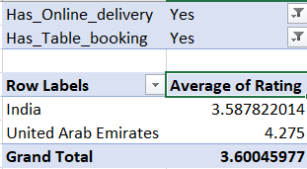 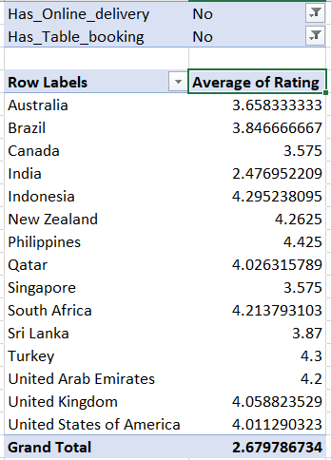

Also, I pasted the different pie charts which show separately the percentage of average ratings for the restaurants that have online deliveries and

the restaurants that have table bookings there slightly a diffrence between them.

**Que8 Should the team keep the rate of cuisines higher? Will that affect the feedback? According to our data are the rates of cuisines and ratings, correlated?**

**Ans8 Approach:** The correlation between the average cost of two and the average rating is not seen to be good as the value is 0.194856293, but the correlation coefficient ranges between -1 to +1, but here our result increases the range which the correlation is not so good between rates or cuisines and ratings. Below chart and pivot table will help in understanding the correlation between both.

**Insights:**

1. Here in below pivot table it shows the correlation between average cost of two in Indian rupees and average rating.
2. Here we get the value 0.194 by using correlation formula between average cost of two and average rating which not seen to very much good.

**Recommendation:**

1. As we can see, there is no correlation between ratings and average cost of the countries.
2. High ratings can be found at various price points, this indicates that there are other factors that play a significant role in determining the ratings and customer satisfaction.

**Below chart is taken from excel sheet named All Pivots and Charts.**

**And the screenshot of value is taken from the sheet named All Pivots and Charts from cell AN26.**

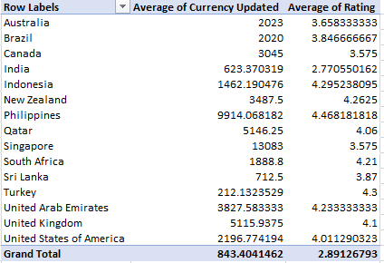

**Que9** **What is the distribution of the number of restaurants of different price ranges in all the countries?**

**Ans9 Approach:** Different countries have different number of restaurants within the different price range. Whereas India have the maximum number of the of the restaurants among all price ranges. States such as the United States, United Kingdom, and South Africa have a more balanced distribution across the different price ranges but with significantly lower totals compared to India. Countries like Indonesia, Sri Lanka, and Qatar, have minimum number of restaurants.

**Insights:**

1. As evident in the Chart, more number of the restaurants i.e. more than 4000 fall under the price range of 1. This indicates that most restaurants offer affordable dining experience.
2. And only few restaurants are in the price range of 4.
3. Number of restaurants gradually reduce as the price range increases. Which may be because of high cost.

**Recommendation:**

1. Opening restaurants in the price range of 1-2 would help us attract a large clientele since we know that majority of the market is between these ranges.
2. Opening restaurants in higher price range like 3-4 would cater to a small audience, offering unique and special dining experience with good quality food may help attract this clientele as they are willing to pay for better experience.

**Below chart is taken from excel sheet named All Pivots and Charts**

**Que10 Explain your approach in brief for suggesting countries/cities in order to open new restaurants, if the objective and subjective questions would have not been given to assist you.**

**Ans10 Country and City Selection Strategy**:

● **Low Competition**: Select countries and cities based on a strategic analysis of restaurant density. The aim is to enter markets with fewer existing restaurants to minimize direct competition and increase the chances of establishing a strong market presence.

● **Quality of Food**: Focused on cities where the average cost for two is high. This suggests a higher spending capacity among customers, which provides an opportunity to introduce affordable yet high-quality food options. By offering competitive pricing, we can attract cost-conscious customers while maintaining a focus on quality.

● **Ratings :** Approach those cities, restaurants and cuisines those which have higher ratings compare to others.

● **Way of Delivery :** Focused on those countries those have online delivery as well as table bookings because it increase the sales of the restaurants.